CHAPTER 5: Ecosystems — flow of energy and matter
Worksheet 5.1

Food webs
Science Quest 9: pages 178–82
Student: Class:
1. Examine the two graphics below and answer the questions that follow.
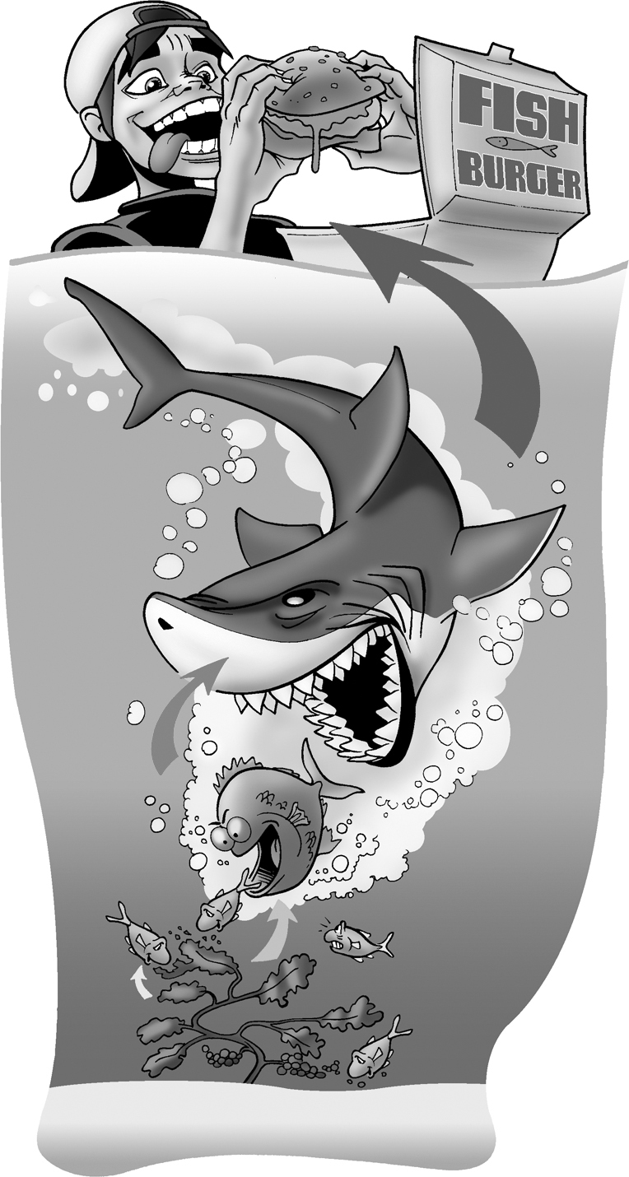 | 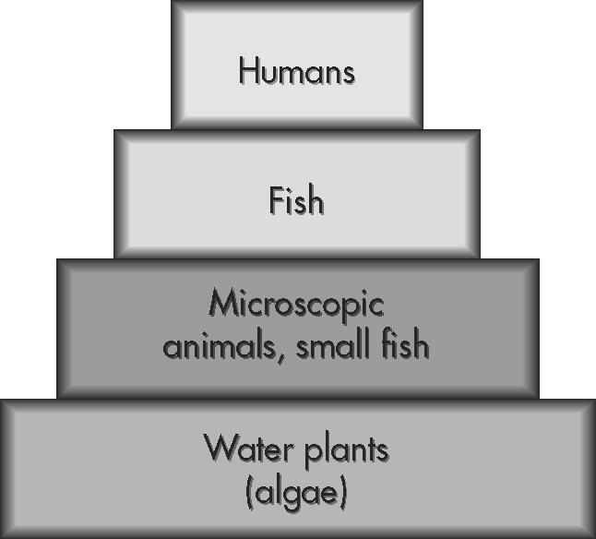
(a) Identify the producers in the food chain.
(b) In this food chain what type of consumer are the humans?
(c) Explain why the food chain is represented as a pyramid.

(d) What is the ultimate source of energy for this food chain?

CHAPTER 5: Ecosystems — flow of energy and matter
Worksheet 5.1

Page 2

2. Examine the food web below and answer the questions that follow.
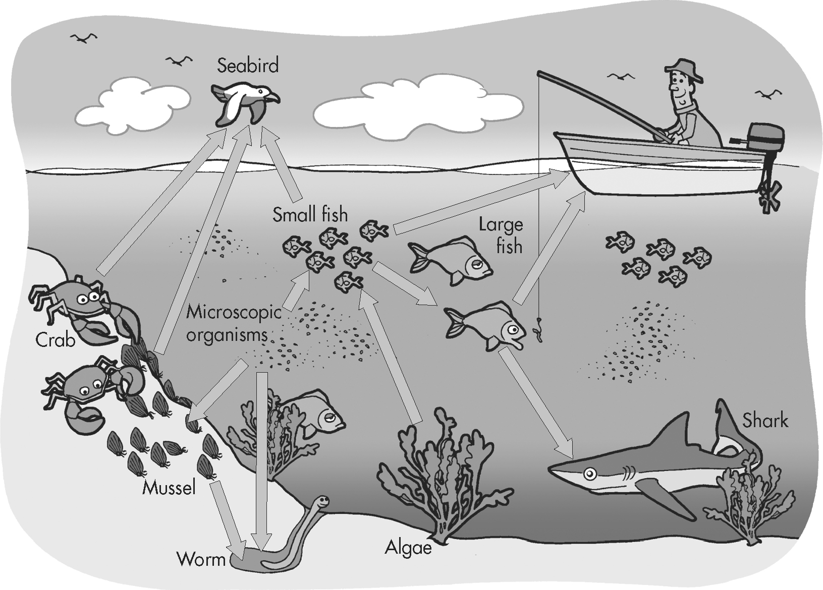
(a) What type of living things could make up the ‘microscopic organisms’?

(b) Write a food chain based on this food web that includes a third order consumer.

(c) If a disease kills all the algae in this area what effect will this have on the food web?

